**Handbook   
Greener Power Solutions B.V.**

**Chapter 1. Introduction   
  
Go Greener!**   
Greener was founded in January 2018 to make an impact on the CO2 footprint of on- and off-grid energy markets, using mobile batteries and smart energy planning.   
 **Inspired by Festivals**The idea of bringing mobile battery systems to events emerged in 2014 after a backstage visit to one of the biggest festivals in The Netherlands.We were shocked to discover how little thought had gone into accurately and efficiently planning the power supply of equipment such as lights, audio and food trucks. And as we looked further, we saw the same lack of planning for energy efficiency in other areas like construction sites and grid maintenance.  
  
Instead, all we could see was unnecessarily massive equipment running on very low efficiency rates. This had to be changed, because Greener is always better!We’re convinced that there are many opportunities to make practices in the energy sector less of a burden on the environment. We see solutions in technological innovation. And we’re bringing these to the market to make our world greener. **Our Batteries**Our pool of batteries help us do the job. Going beyond borders, they’re providing power for all sectors that currently depend on generators. Furthermore, they reduce CO2 and nitrogen emissions and can be used in combination with renewable energies, such as solar and wind power. This leads to less diesel fuel used, as well as a cost-efficient solution due to those savings. Our  
lithium-ion mobile batteries are among the most powerful in the business and can be used as a stand-alone energy source. Furthermore, our batteries are suitable for peak shaving and storage, and can be used in combination with grid connections, diesel generators and renewable energy sources. Our energy solutions functions with any power source and provide real time insights into energy consumption and savings.   
  
**Peak Shaving**  
For energy projects with high capacity demands, our batteries are used to smooth out peak voltages on existing grid connections. The basic capacity comes from the grid and our batteries deliver the power peaks.  
   
**Greener Grid Services**Our mobile batteries relieve congestion on the grid. They increase grid connections power due to seasonal activities. Or simply provide a temporary grid connection when clients are in need of backup power or in need to do maintenance. On the next page you will find the most frequent uses for our batteries.

**Grid Congestion**Electricity supply and peak demand exceeds current grid capacity, causing congestion on the grid. With our batteries we can change these peaks and store energy. Therefore, even a small grid connection can be sufficient in combination with our battery.  
  
**Increase Grid Connection Power**Our batteries are able to expand and increase grid connections for power temporarily. Whether our clients are waiting for their electricity connection or are in need for more power during a certain period of time. **Grid Balancing Solutions (FCR/aFRR)**TenneT, the Dutch national grid operator, certified our battery systems for grid balancing solutions. Besides FCR (R1), our batteries are also able to participate in the aFRR (R2) bidding. Thus, the Greener batteries can act as a Frequency Containment Reserve (FCR) to restore the power balance of the grid if necessary within a maximum of 30 seconds. Additionally,  they can act as an automatic Frequency Restoration Reserve (aFRR) within a maximum of five minutes. This is the secondary reserve and therefore takes over after the FCR. Therefore, our batteries can be used to eliminate grid imbalances.  
  
**Temporary Grid Connection**We deploy a temporary grid connection in a fraction of the time that utility companies need to deploy a permanent grid connection. This ensures that any type of energy problem can be fixed quickly. Additionally, it is a silent and clean solution. Our batteries also work in combination with solar panels and/or other green energy sources, so we can find the most sustainable set-up. **Carbon-Free Construction Sites**Our reliable and clean energy supply on construction site saves up to 100% on diesel consumption and CO2 and nitrogen emissions. Working with Greener can also increase the likelihood to win tenders, especially for construction projects that are near vulnerable nature and in busy cities. On to the zero emission construction site!  
 **Green Energy for Events**We have already powered multiple events across the Netherlands, Belgium, the UK and Switzerland and we are expanding further. We can provide battery power anywhere, from a single cabin up to the main stage of an event. Our batteries reduce an event’s CO2 footprint, prevent local air pollution, eliminate noise, and save money compared to the use of diesel generators alone. Clean energy for any event, anywhere, with any set-up. **Mobile EV Charging**Whether one or twenty charging stations, we can provide for mobile charging for every situation. The chargers are connected to our batteries, which means that charging with our mobile charging stations for electric cars is possible at virtually any location in the world.  **Shore power**By connecting vessels to shore power, we improve the environment. We deliver complete battery solutions for locations were the existing shore power connection is non-existing or insufficient. Our batteries also work in combination with solar panels or other (sustainable) energy sources.

**Chapter 2. Greener Battery**Greener Power Solutions provides rental, monitoring and management of mobile battery systems  
and energy resources. Greener is the owner of the mobile battery systems described in this document.

in dit hoofdstuk een korte functionele beschrijving, en specs vergelijken.   
Het gaat om de volgende systemen:

* Alfen 1.0
* Alfen 2.0
* Alfen 2.b
* Alfen 2.b 422
* Alfen Delta
* Northvolt Voltpack
* Northvolt Grid hub type B
* Northvolt Grid hub type C
* Van Vught/ centurion lood-containers
* WStech omvormers
* Synicell omvormers

**Container**Dimension: 10 ft. Reefer container - 2990 x 2440 x 2590 mmWeight: 8200 kgOperating temperature: -20 ̊ C – 40 ̊ CStorage capacity/power: 336 kWh/318 kVACharging time: Minimum 1 hour, depending on available powerMinimum charging current (grid): 3x400 A/400 VAC – POSITIVE SEQUENCE!Maximum charging current (grid): 3x400 A/400 VAC – POSITIVE SEQUENCE!  
Generator – minimum capacity: 100 kVA with start/stop I/OAccessories (included): None  
Accessories (optional): Phase shift kit, input adaptor-set, EV charger, solar panels, generator, cables, cabinetsInterior: Accessible to technical staff only, not for use for other purposes. Doors equipped with door contacts to secure the system.Start-up (blackstart 24V)*: On-site only  
Start-up (24V online)*: On-site and remote by Greener or customer after trainingInternet: Wireless (4G), ethernet (desirable in case of limited 4G coverage). Internet is necessary for remote support, live reading energy data, changing and setting programs.  
Operation: Locally via HMI, remotely via Greener chatbot, Greener projects or Greener API.

**Connection**  
Input: 1x 400 A PowerSafe (power lock)  
Output main connection: 2x 400 A PowerSafe (power lock)  
Protection (earth leakage): 300 mA (can be bridged)  
Output auxiliary connector: 63 A CEE  
Protection (earth leakage): 300 mA  
DC coupling: No  
External I/O (start-stop): 2 relays remote controlled

**Electric**  
Grid voltage input/output: 3p 230/400 VAC – POSITIVE SEQUENCE!  
Amps (stand alone) (nom.): 400 A/400 VAC for 1 hour with a full battery  
Amps (stand alone) (peak): 500 A/10 seconds  
3Postal and visiting address: Invoices and administration:  
Amps (peakshave) (nom.): 800 A/400 VAC for 1 hour with full battery and 400 A available on input  
Grid frequency: 50 Hz (60 Hz possible)  
Voltage: 400 V +/- 10%  
Storage: 336 kWh, net 280 kWh in normal operation. More available if agreed.  
DC side: 630-800 VDC  
Isolating transformer: The system is equipped with an internal isolating transformer.

**Performance**Climate control: Liquid cooled automotive batteries, container actively ventilated.Efficiency: AC bus offline 0,14% SOC/hour, AC bus online 1,20% SOC/hour

**Standards**NEN3140, NEN3840, **Low Voltage Directive 2014/35/EU**, EMC directive 2014/30/EU, Batteriesdirective 2006/66/EU, HD IEC 60364: 2005, NEN 1010: 2015, IEC 61439-2: 2011, EN 61000-6-2:2005,EN 61000-6-4:2007+A1:2011, IEC 62619: 2017, IEC 60947, IEC 61439, IEC 62271-100, IEC 62271-102,IEC 62271-103, IEC 62271-200. Road and sea transport ADR class 9, UN 3536, UN 3481 (Lithium-IonBatteries in equipment)

**Arrengements (standard)**  
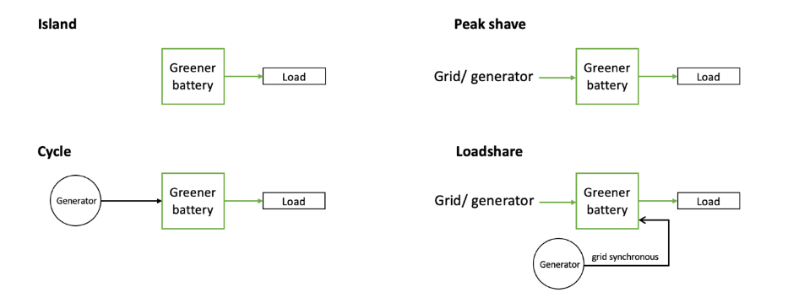

**Transport and on site**- Transport under ADR class 9, UN 3536, UN 3481.   
- Delivery to site with truck-mounted crane or otherwise arranged by customer.

If necessary, move by hoisting; only upper cornercasts. Or with forklift truck using the lift holes.   
  
Check for damage.   
Minimum lifting capacity 10 tonnes.   
  
The battery should be installed on a flat surface;  
Minimum distance from fixed objects 10 metres (target), 5 metres (minimum);  
Minimum 1 metre clearance on all sides of battery;  
Battery must remain accessible to a truck in connection with exchange or emergency access;  
Do not setup the battery install along escape routes;  
Do not setup the battery in the vicinity of unauthorised persons or the public.

**Energy information available during project**Via the 4G connection, data is made available in real time through one of the following channels:  
  
- Average consumption (kW)(7 days), peak consumption (kW)(7 days), energy consumption (kWh)(7 days), SOC (state of charge)(%)(actual), SOC trend (%/h), energy consumption development (graph)(kW)(timeframe user defined). Additional indicators available on request.  
- Chatbot: SOC (state of charge)(%), power in (kW), power out (kW), trend (%/h). Additional  
on demand: current per phase and voltage input and output, temperature and setpoints.  
- HMI: all of the above.

**Control – Greener EMS**Starting up and setting up programs locally or remotely (via Internet) with wizards available via Greener HMI, Greener Chatbot (Telegram), Greener Projects (beta)

Installation wizards  
o Start and stop: starts (power on AC bus) and stops (no power on AC bus).  
o Stand alone: battery is running in island mode and provides power to the user.  
o Peak shaving: battery is connected to a mains connection, and uses it to stay charged. In order not to overload the power source, a maximum input current is set. If the current demand is higher or lower than the energy demand, the battery will charge or disdischarge.  
o Cycle: the battery is connected to 1 or 2 diesel generators that will start automatically when SOC-levels are becoming low. As soon as the battery is fully charged, it will stop the generator and continue to operate in stand-alone mode.  
o Loadshare: the battery is connected to a mains connection to a diesel generator. An extra genset is connected to the output of the battery. This generator can be started by the battery if extra charging is required. The generator must be specially prepared for this set-up; it must run in net synchrony and provide a fixed power output.  
  
Other options (only available within programmes cycle and loadshare)  
o Nightmode: expands the SOC limits to continue the night without charging the generator.  
o Top up/charge: charges the battery to its upper SOC limit by starting the generator after issuing a manual command.  
  
- Solar panels and wind turbines - energy generators - are connected to the output of the battery. The battery will automatically store the surplus of energy produced. Controls are available to curtail or shut down energy production if too much energy is generated.

- Greener also develops project specific software solutions (advanced EMS). Depending on the project specific wishes, energy set-ups are developed with corresponding control software.

**Fire protection**  
- All connections and controls are located on the outside of the system. When the container doors are opened, the system switches off immediately. Note: The container is only completely de-energised when the input grid is switched off (external switching).

- At the HMI there is an emergency stop that switches off the system. Attention: The container is only completely de-energised when the input grid is switched off (external switching).

- The battery system is equipped with active and passive cooling and ventilation systems and temperature monitoring to prevent overheating. In the event of overheating, the system will start sending warnings to the operator and eventually shut down to a safe condition.

- The battery system is equipped with system monitoring. If it appears that the system is not working as expected, the system will start sending warnings to the operator and eventually shut down to a safe condition.   
  
- The battery system is equipped with a fire alarm system. If smoke and/or a high temperature is registered in the container, the system will switch itself off and send a warning to the person who is responsible for the system at that moment and to the alarm centre of Alfen N.V. in Almere. The emergency services can also be notified from here.

Notes:  
* quickstart guide available

**Battery Controls and Connections**

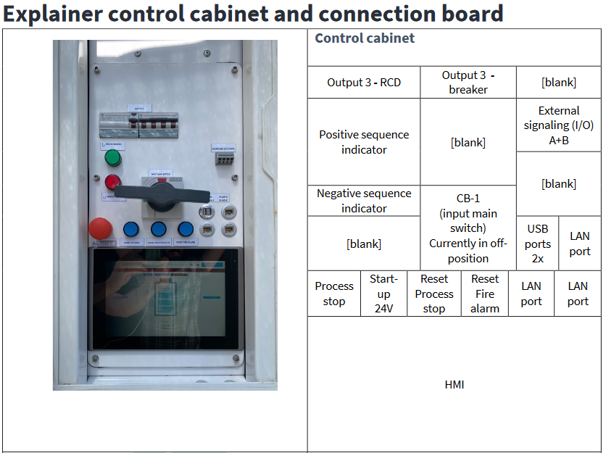

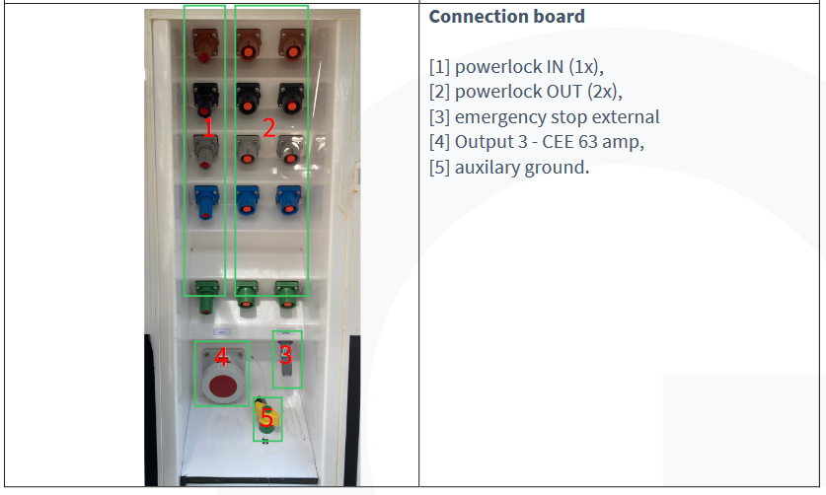

**Chapter 3. Greener@Ops**De inhoud globaal:

* Plaatjes van projecten, kabels, batterijen, generatoren, netwachters, verdeelkasten, hekken, etc
* In de Development meets Ops-presentatie hebben we tabellen over kabel diktes, en kabellengtes, laadtijden, verschil tussen UPS en Back-up, etc.
* Informatie over transport: plaatjes van vrachtwagens met hijskranen en batterijen

**Chapter 4. Electrical Energy**Electrical energy is directly related to forces on electrically charged particles and the movement of electrically charged particles (mostly electrons in wires, but not always). This energy is supplied by the combination of electric current and electric potential that is delivered by an electrical circuit (e.g., provided by an electric power utility such as our batteries).   
  
**Electric Current – Amperès**Electric charge is a property of certain particles atoms, containing electrons (-) and protons (+) and the way they react to each other. Positive particles with the same charge repel each other and particles with an opposing charge attract each other. This allows electric current to run because all the free electrons in the conduction move at the same time, constantly jumping from one atom to another. Each atom therefore always loses an electron, but at the same time also gets electron from the atom before it. All these electrons that jump from atom to atom give together something called electric current. The strength of an electric current is veneered as the number of charge carriers (usually electrons) passing by for a second, this current is called Ampère (A). 1A is defined as 6,241 x 10^18 electrons per second.  
  
**Electric Potential – Voltage**The force that sets the electrons in motion is the voltage. The unit in voltage is Volt (V). If you connect enough voltage to a conductor (copper in the cable) and ensure that the conductor forms a closed path, the free electrons will move in the same direction. A voltage is a measure of the difference in electrical charge between two points. In a battery, negatively charged atoms (atoms with a surplus of electrons) in the majority on one side of the battery are minus pole while positively charged electrons (atoms with a shortage of electrons) in the majority at the other positive pole below escapes a voltage between the two poles. When a conductive path is created between the two battery poles, electrons with a surplus will move to the side with a deficit, trying to neutralize with the difference in charge. **Resistance – Ohms**Voltage, current and resistance are closely related to each other. The connection between these three quantities is better known as "Ohm's Law." The current through a conductor is directly proportional to the potential difference between the ends. Therefor the quotient of voltage and current is a constant. In symbolic notation also called U(voltage) = R(ohms) x I(current).

**Electric Power – Watts**Electric power is the rate at which electrical energy is transferred by an electric circuit. Power can be easily calculated by multiplying the voltage with the current: P(watts) = U(voltage) x I(current).   
  
For example, an outlet with a potential of 230V AC and a current of 16A provides a max. power of 230 x 16 = 3680 Watts. In science, Energy is expressed in Joules, where Power is expressed in Watts. 1 Watt is 1 Joule per second because P(Watts) = E(Joules) / T(seconds). Electrical energy is usually measured by the kilowatt hour(kWh) which is the product of the power in kilowatts multiplied by running time in hours. For example running a washing machine (2500W) for 2 hours the amount of energy needed is a total of 5kWh.

**Alternating Current - AC (voltage)**An electric current that alternates between the positive and negative voltage is called alternating voltage. A clear plus and minus pole is therefore not present because it is constantly changing. Our electricity grid works with alternating current. With alternating currents, the electrons in the wires of a circuit constantly change direction.    With alternating voltage, electrons run from the plus pole to the minus pole and from the minus pole to the plus pole. The current therefore changes direction continuously. How often this happens within 1 second, you call the frequency. In Europe, the current changes direction at 50 times per second and the frequency is therefore 50 Hertz.

**Direct current - DC (voltage)**Direct current, often referred to briefly as DC, is an electric current with constant current direction. Direct current is stored in our batteries and other electronic devices with batteries such as smartphones. The characteristic of this source is that the two poles between which the direct current flows have a fixed polarity. All our battery containers are equipped with a inverter to invert AC to DC for charging and vice versa for decharging.   
  
The chemicals contained in our batteries ensure that the negative and positive electrons do not neutralize each other. A battery becomes active by connecting the negative pole of a load to the positive pole via a conductor. In this way, a closed circuit desegrates and the electrons can flow from postive(+) to negative(-) via the load. The electrons continue to flow until the chemicals become less, the reactions will become less, and the voltage of the battery begins to drop.  
 **Apparent Power -  Volt-Ampères**Voltampere (VA) is used instead of Watts to drip out uncertainties that apply to alternating current circuits.  The actual power consumed depends on the type of equipment that is connected to the circuit. The apparent power equals the product of root mean square voltage (in volts) and root mean square current (in amperes). Volt-amperes are usually used for analyzing alternating current (AC) circuits. In direct current (DC) circuits, this product is equal to the real power, in Watts. The volt-ampere is dimensionally equivalent to the watt: 1 V⋅A = 1 W). Apparent Power with a VA rating is most used for generators and other power handling equipment. For example a 200kVA generator.

**Difference 1 and 3 phase**

**1 phase:**

The phase wire carries the current to the load and the neutral wire provides the return path of the current. Usually, the single-phase voltage is 230V and the frequency is 50Hz or thus 60Hz Since the voltage in a single-phase power supply rises and falls (peaks and troughs), no constant power can be delivered to the load. The design and operation of a single-phase power supply system is often simple.2 Depending on the region, a single-phase power supply is sufficient for loads up to 2500 Watts

Pros: It is a common form of power supply for most minor power requirements. Almost all household power supplies are single-phase power supplies, as the household appliances require a small amount of power to run lights, fans, coolers, heaters, small air conditioners etc.

The design and operation of a single-phase power supply system is often simple. Depending on the region, a single-phase power supply is sufficient for loads up to 2500 Watts

**3 phases**

A three-phase power supply consists of three power wires (or the three phases). Depending on the type of circuit (there are two types: star and delta), you may or may not have a neutral wire. In a three-phase power supply system, each alternating current signal is 1200 out of phase with each other.

In a three-phase power supply, each phase would have had a peak in voltage twice during one cycle of 3600. Also, the power never drops to zero. This steady flow of power and the ability to handle higher loads make a three-phase power supply suitable for industrial and commercial operations.

A three-phase connection has a higher voltage between the phases, in the case of a low-voltage connection in Europe it is usually 400 volts, while the voltage between a phase and the star point is 230 volts.

A power connection has three phase connections and a zero connection. The phases are called L1, L2 and L3.  Connectors for power connection, plug and socket therefore have more pins than usual for the mains.

Power connections are more common in industry, the theatre world, the film industry and construction than in households.

 400V is the voltage between the different phases. With power current you have 3 phases L1, L2, L3 all 230V AC voltage. The sine of those phases run 120º out of sync, so to speak. So, if you measure the voltage between L1 and L2 or L2 and L3 you come to √3 x 230 = 400V (380V at 220V).26 May 2016 

*Difference between alternating voltage and DC voltage.*

**Active/ reactive:**

**Active power**

Active power (kW) and reactive power (kVAR) are the two most common terms used to describe the flow of energy in electrical energy systems. Active power is the real power while reactive power is used for the transfer of real energy.

In simple AC circuits, voltage and current are sinusoidal, which means that the waveform bears a great resemblance to a perfect sine wave. In the case of a purely resistive load (Ohmic load), voltage and current simultaneously reverse their polarity, and at any time the value is positive, which means that the direction of the current does not periodically reverse. In this case, only the active power is transferred. Active power or real power is the amount of current actually consumed in an ALTERNATING CURRENT circuit. In simple terms, the force that is distributed is called active force. It is denoted by the capital "P" and is measured in watts (W), usually kilowatts (KW) and megawatts (MW).

**What is reactive force?**

In the case of purely reactive load, the voltage is not in phase with the current. The product of voltage and current is positive for half of each cycle while it is negative for the other half of the cycle, meaning that the power goes back and forth continuously between the source and the load. This results in reactive power being transferred to the load. In simple terms, reactive power is the unused force or the imaginary force that is not used for any useful work and it exists when voltage and current are out of phase. It is denoted by the capital "Q" and is measured in volt-ampere reactive (VAR) as opposed to the SI unit of power which is watts.

**Difference:** In AC electrical systems, the amount of current used to produce effective work, meaning that the amount of power actually transferred to the load, such as a transformer, is referred to as "active force" or "actual current" or "true force." It is a useful power that is actually drawn by the load due to energy being dissipated as heat. Reactive power, on the other hand, is the amount of power that continuously bounces back and forth between the source and the load, meaning that the power supply cannot be used for effective work in an AC circuit or system.

**Chapter 5. Greener EMS Light**

**Chapter 6. Greener Advanced**

**Arrengements (other)**

**Arrangements (miscellaneous)**- Grid synchronous (ActiveFrontEnd) based on frequency (f), power (P), reactive power (Q) and/ or voltage (U)  
- Peak shaving with external energy meter  
  
Special solutions and more complec EMS on request.  
  
**Braas   
  
Fudura / DKG**

**FCR at De Dijken and Hellegatsplein**

**Chapter 7. Team OPS – does and donts***Ops does and donts – ons NEN3140 beleid, wat doen we wel , wat doen we niet, vuistregels, etc (moet uit het hoofd van Robin en Klaas komen, naast het naast NEN3140-beleid (dit bestaat nog niet))*

**Chapter 8. Manuals and instructions***Handleidingen en instructiekaarten (lilnks toevoegen naar de handleidingen op de drive) (instructiekaarten bestaan nog nauwelijks, maakt Robin, gaan we in Q1 de inhoud van bepalen, en er komen kaarten van Alfen)*